# 

**The blue and yellow represent Legacy Pointe's colors, and the green (growing higher) represents the continuing growth provided by our residents.**

**By Jonathan Wahl**

**APRIL 2024**

# Our Day Begins – Here Comes the Sun

**By Marsha Call**

**OUR FEATURE ARTICLES ON EARTH DAY**

**Earth Day its Start and Today**

Prior to the first Earth Day Americans were introduced to the first call that the environment was in danger from a little-known book called the **Silent Spring** by Rachael Carson in 1962. She focused on the insecticide DDT and what it was doing to our bird population centering on the Bald Eagle and Giant Condors.

The Book caught on and students as well as the public took notice and started to take some action.

Then a fire broke out in 1969 on of all places a waterway. Not in a building, but the fire was in the water. How can water burn?

Fires were nothing out of the ordinary on Cleveland’s Cuyahoga River in the 1960s. The city was still a manufacturing hub and the river, which empties into Lake Erie, had long been a dumping place for sewage and industrial waste. There were so many ‘slugs’ that it caught fire and flames rose 5 stories high.

Again, the attention of the public was captured by ‘water burning’ and a little later the Environmental Protection Agency was formed.

Earth Day was founded in **1970** as a day dedicated to educating people about environmental issues.



**Earth Day 2024**

**is a not a one country event. It is a significant global event that takes place annually.**

on **April 22nd**.

**The theme for Earth Day 2024, is** **“Planet vs. Plastics”**.

**Here are some key points:**

1. **Plastic Reduction**: EARTHDAY.ORG is committed to ending plastics for the sake of human and planetary health. They demand a **60% reduction in the production of ALL plastics by 2040**. Plastics pose risks to humanity and all living creatures, disrupting the delicate balance of life on Earth.
2. **UN Treaty on Plastic Pollution**: The movement aims to rapidly phase out all single-use plastics, urgently push for a strong **UN Treaty on Plastic Pollution**, and call for an end to fast fashion.
3. **Innovative Solutions**: EARTHDAY.ORG advocates for investing in innovative technologies and materials to build a plastic-free world.

The L.P. Independent Times will stay focused on plastic as a threat to our environment throughout 2024. Various articles will appear, and thoughts will be offered on what we at Legacy Pointe can do to make a difference.

**Earth Day at Legacy Pointe by Vickie Carpenter and Maureen Reed**

**Hello It’s Spring!**

And that means Earth Day is coming up! This year we are celebrating Earth Day on Saturday April 20th. We have some special events scheduled from 9 AM to 11 AM in the portico on the 20th. Included is the grand unveiling of the refurbished Butterfly Garden with a Garden Guide to all the plants, highlights of the men’s recycling campaigns including cans, batteries, eyeglasses, and hearing aids, and ideas of how you can impact the environment by making small changes in your life.

Come and join us April 20th, 9-11 AM, for snacks and drinks and watch the Men’s Kan - Kan group demonstrate their impressive steps!

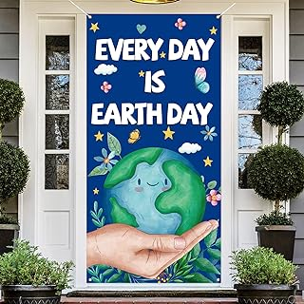

**Welcome Earth Day**

Remember the line from the folk song “where have all the flowers gone? Well just in time for Earth Day we could write a new song starting with the words: “Where have all the bugs, worms, frogs, ducks, and who knows what else have gone”.

If you walk around our pond, you will notice a large ring of brown dead plants (also called invasive weeds). They were alive earlier this week along with all the insects and seeds that feed our wildlife. The food chain is no more. The ducks left. Who knows about the frogs, tadpoles and whatever else was feeding. out

The problem – invasive weeds had started their take over around the edge of pond. And chemicals have been used to take out the invasive weeds. Was it Roundup that was sprayed or something else? What about our pond? What has leeched into the water? Is this a onetime treatment?

Dozens of our residents were involved in getting Legacy Pointe designated as a Wildlife Preserve. It is ironic that in a period of a couple of months that this designation is in danger of just being a sign. We are fencing in the property and spraying chemicals. We need another “Silent Spring Book” before it is too late. There must be a better way to control these weeds.

**Plastics and Recycling by Frank Russo**

Why are we hearing so much about plastics and the failure to recycle most of them? Well, up until recently most of us presumed that when we put our plastics into our recycling bins they were recycled. Answer – not so! Even the numbers on the bottoms of containers meant nothing. Very few plastic bottles were recycled. Most plastics ended up in our land fills or burned as a convenient way of disposal.

We are just learning how dangerous plastics really are! A new term for us to digest is nanoplastics. They are macroplastics which slowly break down over time and turn into micro- and nanoplastics. Microscopic particles of plastic leech off almost all plastics from water bottles to plastic film covering our vegetables, meats, fish, and cheeses. Who knew all this stuff and the dangers inherent in plastics. The chemical companies knew.

**Trash all over the world mostly plastic.**

**“The Companies Knew It”** This should be a familiar story to us who are labelled “Senior Citizens”. We have been through this before. We remember DDT. We were told this chemical was not a problem. And we remember cigarettes and the ads on TV picturing doctors smoking as a perfect way to relax. The manufacturers said there was no problem! And now we are hearing about tiny plastic particles everywhere – in the environment, in our bodies, in our water, in placentas.

Is there a problem. Stay tuned! It will turn out to be a gigantic problem. And we will be living through another medical nightmare.

So, what can we Senior Citizens do. We can raise the alarm and start writing about it. To our friends, to our legislators, to our young people who will probably have the burden of leading the effort to clean up another mess. We have seen billions of tons of this stuff out there. It will take a long time and an unimaginable amount of money to start the process. But it must be done.

**The Machines are fancy, but do they work, and can they process everything?**

**A Breakthrough in Plastic Recycling Is Coming Up Short, a New York times article** see link below.

|  |  |
| --- | --- |
| |  | | --- | |  | |

<https://www.yahoo.com/news/breakthrough-plastic-recycling-coming-short-181111356.html>

**(hold the control key and click on the link or copy it and paste it into your browser).**

**Scientists raise alarm about plastic used in agriculture: 'There are emerging concerns'** Though the use of plastics in agriculture has provided benefits, experts are now raising concerns about potential repercussions. See link below:

<https://www.thecooldown.com/green-tech/agricultural-plastics-environmental-impact/>

**(hold the control key and click on the link or copy it and paste it into your browser).**



Plastics may equal no weeds and less water but what about nanoplastics.

## RESIDENT EDITORIALS

**Recycling continued by Sal Mitchell**

**Recycling** **programs** here at Legacy Pointe are exploding (figuratively speaking of course…).  A number of new programs are just getting off the ground, which you will read about in emails and on Touchtown.  In these communications you will receive more details on these start-up programs. But, in this newsletter, let’s have a quick look at the aluminum cans recycling effort.

**Our few cans will increase and multiply.**

Aluminum Cans.  Hokey smoke!  Residents love recycling these cans!  Maybe because a lot of these cans are pretty!  For whatever reason, the number of cans being recycled keeps growing as more and more people get into it.  In the IL Building the 3rd floor is going nutso!  The number of cans they are producing is ridiculous, which leads the “Can Dancers,” who are processing these cans, to believe that somewhere on the 3rd floor -- possibly in one of the yet-not occupied apartments -- there is an aluminum can manufacturing factory!  We are seeking to determine the whereabouts of this secret facility!

Wait, who are the “Can Dancers?”  The “Can Dancers” are a small elite group of wannabe ballet stars who have shifted (downward!) their expectations of dancing in the Bolshoi (of course there are other factors entering into this as well…).  This group is composed of five (to date): Steve “Lay ‘Em Out” Zimmerman, Jim “Poptop” Reed, Les “Stomp” Tandler, Ross “Big Foot” Williams and Mitch “Aluminum U” Mitchell.  In addition, there is a Phantom of the Opera-type person working stealthily behind the scenes in the midnight hours scooping up the deposited cans throughout the IL Building – the infamous Katherine “Kan Kollector” Mennella.  Other wannabes are now flocking to the dance troupe seeking auditions.

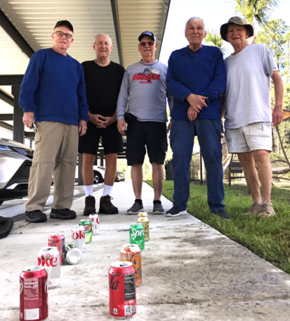

**The Kan, Kan Dancers hard at work**

So, let’s see what’s happening.  In the three weeks or so that the IL Building has been gaining steam in this effort we are seeing about 200 cans per week being generated, and the number is growing.  In the Main Dining Room and Bistro, we are running somewhere around 300 per week, for grand total of about 500 cans each week.  Milwaukee is disappointed: the percentage of beer cans is decidedly on the low side.  We do our can processing most Saturday mornings.  Have you heard of us? The dogs in the Dog Park sure have!

 Some insight:

·         1st floor – you’re WAY behind on aluminum can recycling despite having two (count ‘em 2! Collection sites).  Solution 1: Go steal some of the 3rd floor’s cans. Solution 2: Drink more from aluminum cans, not plastic!

·         Those living out in the “Wilderness, the “Village People,” have also become aware of the can recycling program now that the telephone lines are up on the poles and Morse code can be received. We would like to use one of their Conestoga wagons to collect cans and other recyclables; but, until the contracts, liability forms and permitting processes have been completed, we are recommending that the Pioneer People bring over small numbers of cans at a time, and deposit them in the collection bag behind the counter in the Bistro.

·         Similarly, for those living in Assisted Living,..  For the time being – until we can come up with a fun location for you to deposit your cans in Assisted Living -- please bring your cans – a couple or a few at a time – to the main Dining Room or Bistro when you come over. They will be placed in the main collection bin in the kitchen for the “Can Dancers” to collect.

·         Oh, by the way, thanks to all those who are rinsing out the sticky drink cans!  The “Can Dancers” now don't need to take as many showers in the carwash area after the Saturday can processing dance session.

Finally, we want to thank all of you who are enthused about recycling these cans and we encourage you to jump in and participate in the other programs just getting started.  It’s fun and you really get to know other like-minded people in our Legacy Pointe Neighborhood!

Finally, **Earth Day 2024** is being celebrated at Legacy Pointe on **Saturday April 20th** (The Day is actually Monday April 22nd).  The “Can Dancers” will be performing during the morning celebration at the Legacy Pointe front covered main entrance — and a lot of other FUN things will be taking place.  **BE THERE**!!

On behalf of our growing recycling team!   Mitch ♻️😁♻️

**Recycling Opportunity for Legacy Point residents**

**What can residents do?**

We now have free coffee, tea, etc. in the Bistro. Are you bringing your own cup down or using one of the cups provided in the Bistro. It would help a lot to bring your own cup. There are too many cups in the trash we must do better!

**Single use cups in the trash Even Sunny brings his own cup**

We can do better than one use and throw away. If you forget your cup and have to take one in the Bistro, then take it with you when finished. You can get multiple uses from it. One resident is on her 6th re-use.

**Phone etiquette for the 21st century or BEWARE phone scam.**

submitted by Joe and Linda Solymossy

Linda and I joined two couples at the Sonnentag Theater at the Ice House in Mount Dora yesterday afternoon for SHOUT! The Mod Musical. It was a wonderful trip back into our 1960s. During dinner afterwards, our friend Jay, told us what happened to him the day before. His son is a physician and owns a large practice in Chicago, but lives here in Florida.

Yesterday, Jay looked at his cell phone and recognized a phone call from his son. He picked up the phone and answered, “Hey, how’s it going?” His “son” answered that he was OK, but had been in a car accident. He was not hurt, and the police were on scene, but he had left his wallet at home. The police were taking him to jail, and could his dad send him some money to pay the fine. Jay said it was the right phone number, the correct caller id, and it was my son’s voice, but something wasn’t right. So, Jay said, “What’s the code?” His “son” said, “What?”. “What’s the code?” repeated Jay. His “son” slammed the phone down.

* Jay never mentioned who was calling
* There never was a “code.”

**Lighthouse – What is it and what does it do? by Carolyn Ruhe**

Light House Works and Light House of Central Florida are two local nonprofit organizations that serve the needs of visually impaired individuals. On April 2nd a representatives, Cheryl Rayburn, Vice President of Program Services visited Legacy Pointe at UCF to help residents learn what services and activities are available to residents who have lost or are losing their vision. Lighthouse Works cooperates with local businesses to provide jobs and Lighthouse of Central Florida provides services to visually impaired citizens that help them adjust to normal living.

Classes in activities in daily living help individuals learn how to adjust to activities that will keep them safe, such as, labeling medications, labeling food products, socializing with friends at restaurants, cooking and eating meals and many other activities.

Legacy Pointe resident, Carolyn Ruhe, demonstrated several options for “reading” through audio and talking books. If your vision is decreasing, then contact Light House to learn if -you qualify for these ‘free’ services at 407-898-2483. Also contact the Braile and Talking Books Library in Daytona to find out if you qualify at [(800) 226-6075](tel:8002266075).

**More Springtime in Nature**

Our Latest Avian Residents at Legacy Pointe by Tony Mennella

**The Male Bluebird scouts out the Nest Box. The Female Bluebird also checks it out.**

**Photos by Tony Mennella**

During the past two weeks we have witnessed a flurry of activity surrounding our bluebird nesting box located between the garden shed and the lift station. A group of male bluebirds draped in their radiant bright blue were in full competition for the sole rights of courtship with a comely maiden poised to select the victor. After many skirmishes and aerial combat, a victor was crowned who immediately began to woo his young maiden with song and fluttering while persistently luring her to the nesting box which he had already been preparing.

There are three species of bluebirds in North America. The Western Bluebird (western part of North America from southern Canada to Central America); the Mountain Bluebird (central Alaska to southern Mexico); and the Eastern Bluebird (throughout the United States east of the Rocky Mountains from southern Canada to Central America). The Eastern Bluebird is the most common and is found throughout Florida. Most Eastern Bluebirds stay in their area year-round while some migrate south during the colder winter weather.

The Eastern Bluebird is 6-8 inches long with a wingspan of 9-12 inches. The adult males have a bright blue forehead, crown, shoulders, back, wings and tail. The throat and breast are orange rust; the belly is white. The bill, eyes and feet are black. The adult female has pale blue-gray upper parts and gray-brown wash on the back. The wings and tail are a dull blue, and the throat and breast are a paler rust. The juveniles have brownish plumage with white streaking above and white spotting below. The average life span in the wild is 6-8 years.

The Eastern Bluebird is primarily an insectivore and can spot their insect prey as far as 60 feet away from their perch on a tree limb or post. They prefer soft-bodied insects such as dragonflies, spiders, caterpillars, butterflies, small worms, grasshoppers, and cutworms. They will eat natural berries when the insect population diminishes.

The Male checks out a tight squeeze The Female approves. Starts nest building.

Bluebirds are typically monogamous and breed in their first year. They are cavity nesters in that they build their nest within an existing cavity such as a tree hollow or in a nesting box. The nesting material is typically made up of dry grass, weeds, and small twigs lined with finer grass or animal hair at the center. The female does most of the nest building.

Females will usually lay 3-6 pale blue eggs. The incubation period is 13-16 days. Usually, 80% of the eggs will hatch. Both parents share the feeding responsibility. Within 13-14 days the nestlings are fully feathered and will leave their nest in 18-21 days. The parents will continue feeding the youngsters up to three weeks after they have left their nest. The parents may raise 2 or 3 broods a year.

Nesting boxes to attract bluebirds have been in use since early colonial days once farmers recognized the bluebirds’ significant role in the control of the insect population. In the 1920s, the concept of “bluebird trails” was introduced to replace the loss of natural cavities. Today, this practice has proven to be a significant factor in supporting the growth of the bluebird population.

In addition to habitat loss, the bluebird population has declined with the introduction of the European Starling and the House Sparrow which outcompete the bluebird for natural nesting sites. The accidental importation of fire ants in the South has also proven to be a major problem on bluebird trails. Typically, the fire ants will form a mound at the base of the nesting box pole and subsequently invade the nest and eat the nestlings. In addition to habitat loss, climate change, severe storms and hurricanes, the bluebirds can be preyed upon by hawks, small mammals, and snakes. The use of predator guards (like the one we have installed) has been successful in reducing snake predation.

Kathryn and I placed our first three nesting boxes on our one-acre property in Gainesville in 1989 and were rewarded every year with successful hatchlings and frequent multiple broods. Six years ago, I placed two nesting boxes on my sister’s one quarter acre lot in a dense subdivision abutting a heavily wooded park and open fields. She continues to have successful nesting and hatchlings every year.

Our “Bluebird Trail” consisting of 3 nesting boxes at Legacy Pointe at UCF extends another “helping hand” to our native bluebirds who bring joy and happiness to our shared “Wildlife Habitat”.

**The Tech Corner by Joe Solymossy**

Very recent events have shown us the need for even more vigilance in keeping our electronic communication systems current with the latest updates. This month’s Tech Corner will focus on Apple products For the Apple users, the following web site will continue to give you a running list of the latest security releases by Apple; [Apple security releases - Apple Support](https://support.apple.com/en-us/HT201222)  (hold the control key and click on the link or copy it and paste it into your browser).

**(The LP Tech class on April 16 will be on WIN 11 for Microsoft computer users).**

**RECENT NEWS AND EVENTS**

**Parkinson’s Fundraiser at Legacy Pointe**

**Join with others across the Country and the World**

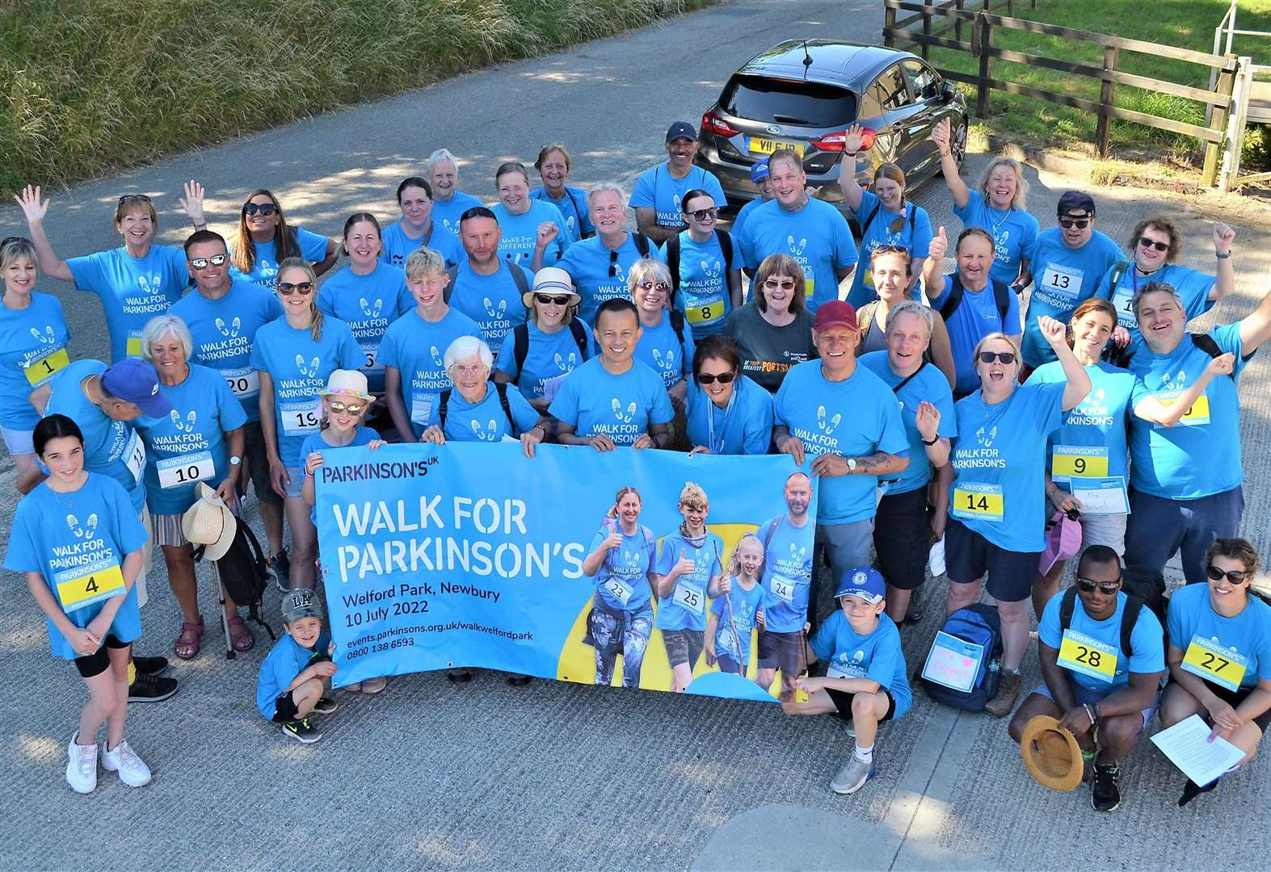

At a special meeting Monday night, hosted by Anita and Don Ford, over 40 of your fellow residents resolved to hold a walk around our pond on Saturday, April 27 in the morning, to raise donations for the Parkinson's Foundation.

Parkinson’s disease (PD) is a progressive neurodegenerative disorder. Over 10 million people worldwide are afflicted. With 90,000+ diagnosed in the U.S. alone.

You are receiving this brief note now because we will begin "manning" donation tables Tuesday afternoon outside the dining room. Donations over $40 will receive a Commemorative T-shirt. Please, checks only, made out to "Parkinson's Foundation". Check out their website at Parkinson.org.

Residents of L.P. have set an ambitious goal of trying to raise $5,000 for this first fundraiser. So, to reach this goal, please be generous.

Much more information will follow in the coming days. The next meeting is Sunday 04-14 at 6 PM in the card room. Please bring $5 for pizza and byob.

We all thank you in advance for your generous support!

**Prepared by Tom Nixon, Lifestyles**

**St Lukes Concert Series**

The final concert at St. Lukes Church is scheduled for Friday April 26th at 7 PM. The featured musical group is the Orlando Concert Band. There will be bus transportation from L.P.

**UCF Celebrates the Arts**

**Photos by Denise Tate**

Each year during the first two weeks in April (April 3 – 14) UCF celebrates the Arts takes over the Dr Phillips Center and the Steinmetz Hall to showcase the students at UCF and their various art forms.

This year the venues vary from music, theater, choral, poetry, opera, architecture, concert band competition, Sweeney Todd, National Young Composers Challenge, and more.

**The Flying Horse Big Band: Feels Like Rain**

**Your New Year’s – Resolution???**

Each month in our newsletter we are doing some checking with you about your New Year’s resolutions to get into shape and to stay healthy. Here is a good rule of thumb about when you will start feeling great because of your exercise program. You will need one month working your program for every year that you have done no exercise. So, if you have not done anything in 12 years it will take approximately 12 months in your new routines to feel that you are making progress and feel good about what you are doing.

That may sound a bit overwhelming but just think. If you had not done anything for 12 years and had started in January, you would already be 3+ months into your routine. You would notice the difference.

If you haven’t started yet, then get off your chair and move. There are a number of programs here at L.P. Jump in and start. There are still 9 months left in the year.

## L.P. RESIDENT EVENTS

**What happened during March?**

Oviedo Community News

Megan Stokes

In the Legacy auditorium on Friday, March 2, Megan Stokes, Editor-in-Chief of the Oviedo Community News, spoke to us about her non-profit online local news publication. They publish a newsletter weekly for the Oviedo/Winter Springs community. The information is about what is happening around us in Seminole County. They have no editorial viewpoint. In addition to the newsletter their website contains several other useful guidebooks.

As stated on their website, their mission is “To create a better informed and connected community through independent, public-service journalism that focuses on issues that residents told us matter to them.”

Check out their free website: OviedoCommunityNews.org.

Article by Tom Nixon

**Guess who and Guess what?**

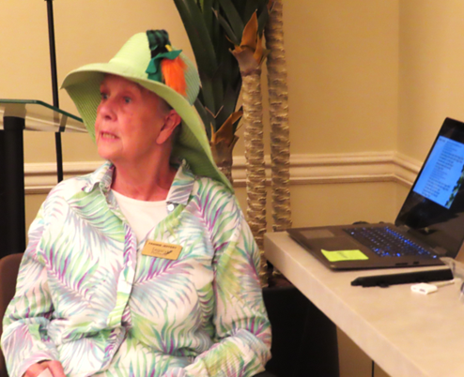

**Photos by Vicki Tindall**

Well it is not much of a Guess What? St Patrick’s Day Party came to L.P. on Sunday March 17th. And everybody dressed up and had a great time in the auditorium. And as usual entertainment was provided by Niall and Glenda Donoghue along with their musical quartet.

**Niall Donoghue giving a little bit of Irish wisdom and song to the gathered residents.**

**Inaugural Cornhole Contest by Tom Nixon**

The Fifth Floor held their monthly Afternoon at the Bistro on Sunday, March 24. In addition to the usual delectable edibles, the recent Lifestyles purchase of a cornhole game was deployed. A rousing competition amongst those present ensued. Both men and women vied to sink the beanbag for a coveted three pointer. Hopefully, this inaugural competition will lead to a weekly/monthly Cornhole Competition among all interested residents.

**Margaret Ziegler is about to sink one**

**Whoever thought we would see this guest drop in to L.P.**

The Easter Bunny arrived at the start of the Easter Buffett Dinner. It was hard to figure who was having the most fun – the Bunny or the Residents.

But we do know that the buffet was the hit of the day. The food was excellent, the variety great and the portions very generous. The residents and their invited guests raved about the food and the service. Thank you to our great kitchen staff and servers.

**Resident Feedback Form**

One of our residents submitted a suggestion which should appear in every edition of the L.P. Independent Times. Here is the suggestion from Jonathan Wahl

“I think you should encourage readers to fill out the short Feedback form.  …. the completed forms are sent directly to the L.P. Independent Times email address.  Here's what I think you might request:

***"Are you enjoying the monthly newsletters? Do you have suggestions for how we can improve them?  
Please feel free to let us know your thoughts by filling out our short Feedback form.”  
Click the link below to begin ... and thank you!"***

[**https://lpresidentsonline.org/Form/Feedbackform.html**](https://lpresidentsonline.org/Form/Feedbackform.html)

Sign up for the **LP Residents Forum**: [**https://lpresidentsonline.org/smf**](https://lpresidentsonline.org/smf/index.php)  **You can easily set up your login and password.** TheForum is a place for you and your neighbors to come together . . . To create a knowledge base . . . To go beyond a community to becoming a family. We hope to see you online soon. If you need help contact by email Jonathan or Ina.

Email Jonathan at 47ipsd@gmail.com or Ina at utgrad@attglobal.net.

**Legacy Pointe Residents** are going to so many places we cannot keep up with them. Here are some of their outings:

An Outing to Victorios Restaurant:

**More Signs and Dangers of Spring**

**Look what I See - Food below Calling all Chicks - Danger above**

**Photos by Vicki Tindall**

## HEALTH AND MORE

## Social, Physical, and Nutritional aspects of ‘senior living’.

**Each month, here are articles about social fitness, physical fitness, and nutritional fitness. They are for your interest. We do not make any claims or recommendations.**

|  |  |  |  |
| --- | --- | --- | --- |
| **Social Fitness:**  More studies stress your need to nurture your ‘social fitness’. Social Media Communication and Loneliness Among Older Adults: The Mediating Roles of Social Support and Social Contact. Here is a link to the article:  **[Social Interactions and Well-Being: The Surprising Power](https://www.bing.com/ck/a?!&&p=34aca2c8a2c638e2JmltdHM9MTcxMjYyMDgwMCZpZ3VpZD0xZTEwMGViYi1kNWM3LTZkNzgtMWM1Yi0xYTliZDRhYjZjMWYmaW5zaWQ9NTUyNg&ptn=3&ver=2&hsh=3&fclid=1e100ebb-d5c7-6d78-1c5b-1a9bd4ab6c1f&psq=Social+interaction+and+aging&u=a1aHR0cHM6Ly9wdWJtZWQubmNiaS5ubG0ubmloLmdvdi8yNDc2OTczOS8&ntb=1" \t "_blank)**[of …](https://www.bing.com/ck/a?!&&p=34aca2c8a2c638e2JmltdHM9MTcxMjYyMDgwMCZpZ3VpZD0xZTEwMGViYi1kNWM3LTZkNzgtMWM1Yi0xYTliZDRhYjZjMWYmaW5zaWQ9NTUyNg&ptn=3&ver=2&hsh=3&fclid=1e100ebb-d5c7-6d78-1c5b-1a9bd4ab6c1f&psq=Social+interaction+and+aging&u=a1aHR0cHM6Ly9wdWJtZWQubmNiaS5ubG0ubmloLmdvdi8yNDc2OTczOS8&ntb=1" \t "_blank) |  |  | https://mail.google.com/mail/u/0/images/cleardot.gif  https://mail.google.com/mail/u/0/images/cleardot.gif  https://mail.google.com/mail/u/0/images/cleardot.gif |

**(hold the control key and click on the link or copy it and paste it into your browser).**

**Physical Fitness**

Does exercise help to strengthen your brain? Good question!

There are still some ‘nay-sayers’ but that audience is shrinking. The article below involves two heavy hitters – Mass General Hospital – Harvard School of Medicine, and the New York Times. It will discuss the science behind exercise and the brain.

Article submitted by Sharon Lovell

<https://www.nytimes.com/2024/04/02/well/mind/exercise-mental-health-cognition.html?unlocked_article_code=1.hk0.lj2K.3XaWeuXpe-TF&smid=nytcore-ios-share&referringSource=articleShare>

**(hold the control key and click on the link or copy it and paste it into your browser).**

**Nutritional Fitness :**

As we age, maintaining a **healthy diet** becomes increasingly crucial for overall well-being. Let’s explore why and how seniors can benefit from making nutritious choices:

1. **Physical Health**:
   * [**Weight Management**: A balanced diet helps seniors maintain a healthy weight, which is essential for preventing chronic conditions like **heart disease** and **diabetes**](https://health.clevelandclinic.org/how-to-age-better-by-eating-more-healthfully)[1](https://health.clevelandclinic.org/how-to-age-better-by-eating-more-healthfully)[2](https://www.healthline.com/health/healthy-eating-for-seniors).
   * [**Bone Strength**: Adequate nutrition supports bone health, reducing the risk of **osteoporosis** and fractures](https://health.clevelandclinic.org/how-to-age-better-by-eating-more-healthfully)[1](https://health.clevelandclinic.org/how-to-age-better-by-eating-more-healthfully).
   * [**Muscle Tone**: Proper protein intake helps preserve muscle mass and strength, promoting independence and mobility](https://health.clevelandclinic.org/how-to-age-better-by-eating-more-healthfully)[1](https://health.clevelandclinic.org/how-to-age-better-by-eating-more-healthfully).
   * [**Heart Health**: A heart-healthy diet lowers the risk of cardiovascular diseases](https://health.clevelandclinic.org/how-to-age-better-by-eating-more-healthfully)[1](https://health.clevelandclinic.org/how-to-age-better-by-eating-more-healthfully).
   * [**Gastrointestinal Function**: Nutrient-rich foods aid digestion and prevent gastrointestinal issues](https://health.clevelandclinic.org/how-to-age-better-by-eating-more-healthfully)[1](https://health.clevelandclinic.org/how-to-age-better-by-eating-more-healthfully).
2. **Mental and Emotional Well-Being**:
   * [**Brain Function**: A healthy diet positively impacts brain health and memory function](https://health.clevelandclinic.org/how-to-age-better-by-eating-more-healthfully)[1](https://health.clevelandclinic.org/how-to-age-better-by-eating-more-healthfully).
   * [**Emotional Health**: Proper nutrition contributes to emotional well-being, especially during life changes like the loss of a spouse](https://health.clevelandclinic.org/how-to-age-better-by-eating-more-healthfully)[1](https://health.clevelandclinic.org/how-to-age-better-by-eating-more-healthfully).
3. **Immunity and Disease Prevention**:
   * [**Boosted Immunity**: Nutrient-rich foods strengthen the immune system, helping seniors fight off illnesses](https://health.clevelandclinic.org/how-to-age-better-by-eating-more-healthfully)[1](https://health.clevelandclinic.org/how-to-age-better-by-eating-more-healthfully).
   * [**Reduced Disease Risk**: A good diet lowers the risk of conditions such as **high blood pressure**, **type 2 diabetes**, and certain cancers](https://health.clevelandclinic.org/how-to-age-better-by-eating-more-healthfully)[1](https://health.clevelandclinic.org/how-to-age-better-by-eating-more-healthfully).
4. **Independence and Quality of Life**:
   * [**Energy Levels**: Eating well provides the energy needed for daily activities and enhances independence](https://health.clevelandclinic.org/how-to-age-better-by-eating-more-healthfully)[3](https://www.helpguide.org/articles/healthy-eating/eating-well-as-you-age.htm).
   * [**Reduced Falls**: Proper nutrition helps prevent muscle and bone loss, reducing the risk of falls and fractures](https://health.clevelandclinic.org/how-to-age-better-by-eating-more-healthfully)[4](https://food-guide.canada.ca/en/tips-for-healthy-eating/seniors/).

In summary, seniors should focus on a diet rich in **lean protein**, **fruits**, and **vegetables**, while limiting added sugars. Prioritizing nutrition supports both physical health and mental well-being, allowing seniors to age gracefully and maintain their vitality. 🌱🥦🍎



**\DO YOU NEED TO GET OUT AND DO SOMETHING?**

***Check out these possibilities:***

**IF YOU DO NOT WANT TO GO OUT, BELOW ARE OPPORTUNITIES IF YOU STAY IN.**

**CHECK OUT TOUCH TOWN JOIN a CLUB**

Check out Touch Town on your phone. There are over a dozen clubs here at Legacy Pointe that would love to have you join. Also in the Card Room there are many activities each day some starting at 7 AM

Here are just a few available The Legacy Pointe Book Club, Garden Club, Chess Club, and many others. Check Touch Town for dates and times of many others.

**The Legacy Pointe Book Club**

***Our Book for April is called “Me Before You” by Jojo Moyes***

**From the #1 *New York Times* bestselling author of *The Giver of Stars*, discover the love story that captured over 20 million hearts in *Me Before You*, *After You*, and *Still Me*.**  
  
They had nothing in common until love gave them everything to lose . . .  
  
Louisa Clark is an ordinary girl living an exceedingly ordinary life—steady boyfriend, close family—who has barely been farther afield than their tiny village. She takes a badly needed job working for ex–Master of the Universe Will Traynor, who is wheelchair bound after an accident. Will has always lived a huge life—big deals, extreme sports, worldwide travel—and now he’s pretty sure he cannot live the way he is

***Our Book for May is called “Next Year in Havana” by Chanel Cleeton***



Havana, 1958. The daughter of a sugar baron, nineteen-year-old Elisa Perez is part of Cuba's high society, where she is largely sheltered from the country's growing political unrest—until she embarks on a clandestine affair with a passionate revolutionary...  
  
Miami, 2017. Freelance writer Marisol Ferrera grew up hearing romantic stories of Cuba from her late grandmother Elisa, who was forced to flee with her family during the revolution. Elisa's last wish was for Marisol to scatter her ashes in the country of her birth.  
  
Arriving in Havana, Marisol comes face-to-face with the contrast of Cuba's tropical, timeless beauty and its perilous political climate. When more family history comes to light and Marisol finds herself attracted to a man with secrets of his own, she'll need the lessons of her grandmother's past to help her understand the true meaning of courage.

## SPACE LAUNCHES AT KENNEDY SPACE CENTER FOR APRIL 2024



## Photo by Joyce Swing

## For list of all launches, check this website suggested by John Boldt

[**https://nextspaceflight.com/launches/**](https://nextspaceflight.com/launches/)

## SURFING THE INTERNET

You could spend your whole day just sitting and surfing. If you do this your entire body will fall apart from lack of exercise. So, our newsletter is asking its readers who spend just a few minutes a day surfing to send along some links to articles that may be interesting or funny or extremely important. Send links to Frank Russo at [frankrusso2012@gmail.com](mailto:frankrusso2012@gmail.com)

**Some new scientific possibilities for breaking the microplastic cycle**

#### [**https://scitechdaily.com/revolutionary-plant-based-polymers-promise-to-break-the-microplastic-cycle/**](https://scitechdaily.com/revolutionary-plant-based-polymers-promise-to-break-the-microplastic-cycle/) **(hold the control key and click on the link or copy it and paste it into your browser).**

**Feedback? Stories? Photos?**

**Send to Frank Russo** at frankrusso2012@gmail.com

REMEMBER sign up for the **LP Residents Forum**: [**https://lpresidentsonline.org/smf**](https://lpresidentsonline.org/smf/index.php)  **You can easily set up your login and password.** TheForum is a place for you and your neighbors to come together . . . To create a knowledge base . . . To go beyond a community to becoming a family. We hope to see you online soon. If you need help, contact by email Jonathan or Ina.

"And in case you missed any issues, click the following link to access the complete Newsletter Archive:"

[LP Residents Forum - Residents Newsletters **(lpresidentsonline.org**)](https://lpresidentsonline.org/newsletters/newsletters.html)

Email Jonathan at 47ipsd@gmail.com or Ina at utgrad@attglobal.net.

**Our Day Ends**

**Here comes the Moon.**

**Photo by Polly Del Vero**